PROJECT FUNDING
EXPRESSION OF INTEREST

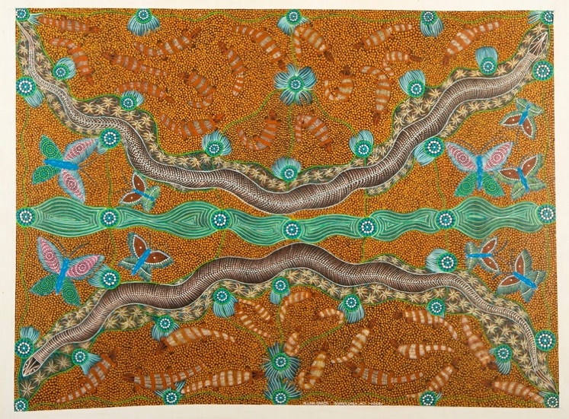
The McArthur River Mine Community Benefits Trust supports the social and economic development of the Gulf region.

This form can be used to express your interest to apply for grant funding for programs or projects to be implemented for the benefit of this regional community. Please refer to the Project Funding Guidelines for more information.

CONTACT DETAILS
The organisation is the body applying for the grant and undertaking the proposed project or activity.
Organisation

Contact Name

Position

Phone number

Email address

Postal Address

GRANT DETAILS

Amount (ex. GST)

Total Project Cost

Timeframe

PROJECT DETAILS

Project Name

Project Overview
Provide an overview description of the project requiring funding including its current status.

Please provide detail of any funding sources you have applied for in undertaking this project AND/OR funding sources you receive as an organisation pertinent to the project.
Funding Source (who is providing your other funding) | Detail  (amount of funding sought, timeframe for delivery, milestones, associated commitments etc.) | Status  (has the funding been awarded is it pending, is it on-going, has it been unsuccessful)

If you have sought additional grants or sources of funding for your project, please attach evidence (e.g. correspondence, funding agreements) along with the submission of this Expression of Interest.

ELIGIBILITY CHECKLISTS
Please confirm that the organisation is eligible to apply for a grant by ticking the relevant box below.
Incorporated under the Associations Act 2003 (NT)
Incorporated with not-for-profit objectives under the Corporations Act 2001 (Cth)
Incorporated under the Co-operatives (National Uniform Legislation) Act 2015 (NT)
Incorporated under the Aboriginal Councils and Associations Act 1976 (Cth)
An organisation with not-for-profit objectives incorporated by an Act of Parliament and which is approved by the Treasurer of the Northern Territory or Commonwealth of Australia.
Other (please specify)
Click here to enter text.
Please confirm that you are able to attain the following documents for the Application
Proof of Title
Proof of Incorporation
Details of Affiliation(s)

Please also note the following requirements (for relevant projects) prior to submitting a Full Application:
- Support from local Elders - for Aboriginal culture, arts and/or storytelling projects
- Support (in writing) from School Council - for education, sport and young people’s programs
- Support (in writing) from Gulf Youth and Community Service – for young people’s programs
- Evidence of approvals and land tenure – for construction and development projects

SUBMIT EOI
Expressions of Interest should be submitted online or by email to the following address. For further information, please contact the Trust Project Officers at the email or number below.
Email: cbt@planc.com.au
Enquiries: Jim Gleeson 0422 794 072

