ACADEMIC ASSISTANCE BURSARY APPLICATION FORM

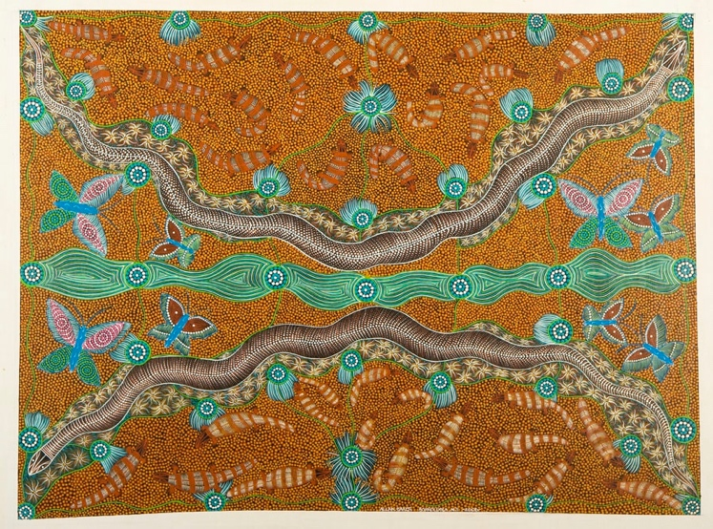
The McArthur River Mine Community Benefits Trust supports the social and economic development of the Gulf region.

The Academic Assistance Bursary seeks to provide funding to support secondary school students in Borroloola, Robinson River, Outstations and Town Camps attending school locally or elsewhere to purchase essential IT equipment for school.

This form can be used to apply for the funding to the CBT for the Academic Assistance Bursary. Please refer to the Program Guidelines for more information.

- SCHOOL DETAILS
Name of School
Legal Entity

ACN

ABN

Are you currently registered for Goods and Services Tax (GST)? YES NO
Postal Address

Telephone |  | Facsimile

Email address

- CONTACT PERSON DETAILS
For inquiries regarding the application
Name

Position

Telephone |  | Facsimile

Email address

- ACCOUNTABLE PERSON DETAILS
Name

Position

Telephone |  | Facsimile

Email address

- DETAILS OF FUNDING APPLICATION

- One-off payment of up to $1650 (ex GST) available per student, including insurance.
- Available to purchase IT equipment only

Items to be purchased

No. | Item/Equipment  (attach quotes for items) | Cost of item | Insurance cost | Total (ex GST) | Total  (inc GST) | Student details (name and place of residence) | Student DOB
 | e.g. laptop details
Add more rows as required.

TOTAL VALUE OF APPLICATION: $

N.B. Students' names, places of residence and DOB’s are for record-keeping purposes only.

- REPORTING REQUIREMENTS
Schools will be required to provide an outcomes report to the CBT outlining the benefits the purchased items have had for the students. This report will be due ahead of the August Board meeting (date TBA).
- SUBMIT APPLICATION
Applications are due two weeks before the November CBT Board meeting (date TBA). Applications should be submitted by email to the following address. For further information, please contact the Trust Project Officers at the email provided below.
CBT Project Officer
email: cbt@planc.com.au

