PROJECT FUNDING
EXPRESSION OF INTEREST

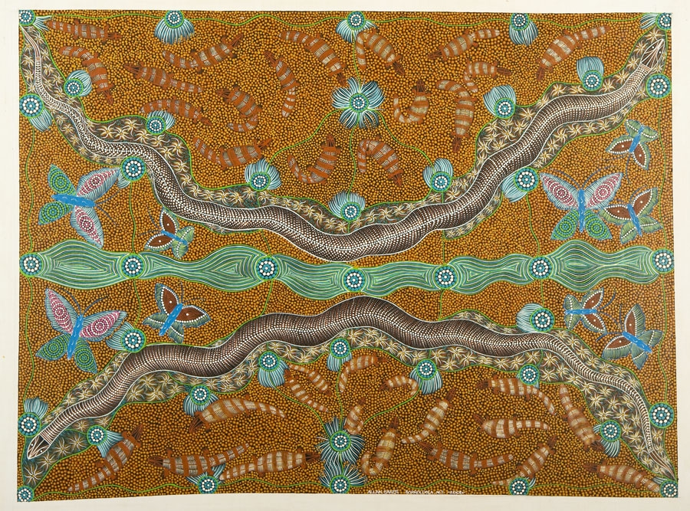
The McArthur River Mine Community Benefits Trust supports the social and economic development of the Gulf region.

This form can be used to express your interest to apply for grant funding for programs or projects to be implemented for the benefit of this regional community. Please refer to the Project Funding Guidelines for more information.

CONTACT DETAILS
The organisation is the body applying for the grant and undertaking the proposed project or activity.
Organisation | Click here to enter the organisation name.

Contact Name | Click here to enter text.

Position | Click here to enter text.

Phone number | Click here to enter text.

Email address | Click here to enter text.

Postal Address | Click here to enter text.
 | Click here to enter text.

GRANT DETAILS

Amount (ex. GST) | Click here to enter the amount requested.

Total Project Cost | Click here to enter the total cost of the project.

Timeframe | Click here to enter the proposed start date and finish date for your project.

PROJECT DETAILS

Project Name

Click here to enter text.

Project Overview
Provide an overview description of the project including its current status.
Click here to enter text.

ELIGIBILITY CHECKLISTS
Please confirm that the organisation is eligible to apply for a grant by ticking the relevant box below.
Incorporated under the Associations Incorporation Act 1981 Associations Act 2003 (NT)
Incorporated with non-profit not-for-profit objectives under the Corporations Law Corporations Act 2001 (Cth)
Incorporated under the Co-operatives Act 1997Co-operatives (National Uniform Legislation) Act 2015 (NT)
Incorporated under the Aboriginal Councils and Associations Act 1976 (Cth)
Incorporated under the Community Services (Aborigines) Act 1984
Incorporated under the Community Services (Torres Strait) Act 1984
An organisation with non-profit not-for-profit objectives incorporated by an Act of Parliament and which is approved by the Treasurer of the Northern Territory or Commonwealth of Australia.
Other (please specify)
Click here to enter text.

Please confirm that you are able to attain the following documents for the Application
Proof of Title
Proof of Incorporation
Details of Affiliation(s)

Please also note the following requirements (for relevant projects) prior to submitting a Full Application:
- Support from local Elders - for Aboriginal culture, arts and/or storytelling projects
- Support (in writing) from School Council - for education, sport and young people’s programs
- Evidence of approvals and land tenure – for construction and development projects

SUBMIT EOI
Expressions of Interest should be submitted by email to the following address. For further information, please contact the Trust Project Officers at the email or number below.
Email: cbt@planc.com.au
Enquiries: Jim Gleeson 0422 794 072

